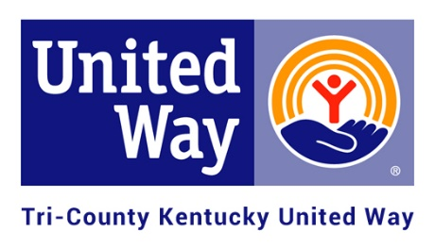
2021 APPLICATION FOR FUNDING
Checklist

The deadline for submission of this application is 12:00 noon on December 4th, 2020.

Eligibility:
Yes/No | Requirement
 | Are you a valid 501(c)3 organization or local school district program?
 | Do you serve individuals in Marion, Nelson and/or Washington Counties?
 | Are you a health and human service organization providing service in at least one of the following United Way priority areas: Education, Financial Stability or Health?
 | Have you been in existence for at least two full years and have filed an annual audit or IRS 990?

Required Information to be submitted:
Submitted | Requirement
 | Two (2) hard copies of your full application – one marked “Copy” and one marked “Original.” Please use a binder clip to secure each full application. If dropping off to United Way in person, please email director@tricountykyuw.org to ensure that someone can meet you at the office at a designated time.
 | Emailed a full application packet to director@tricountykyuw.org
 | Program budgets for the program for which you are seeking funding (please use attached forms).
 | Signed copy of Agency Agreement (please use attached form).
 | Anti-terrorism Compliance (please use attached form).
 | Most recent agency Financial Statement/Audit/990 (as applicable). Only need to submit signature page, revenue page, and expenses page (not entire 990).
 | IRS letter confirming your exempt status under the 501(c)3 status or as a school, if not provided in past.
 | Current Board Roster with designation of officers and affiliations.
 | A copy of your Non-Discrimination Policy.
 | A success story from program for which you are seeking funding. Please do not use real names.
 | Copy of your registration with Kentucky Secretary of State (available through https://app.sos.ky.gov/ftsearch/).
 | Optional: Please provide a picture of your requested program’s services that can be used for marketing materials (social media, brochure, etc.).
 | Optional: Program/Agency brochure, newsletter, and/or annual report.

Thank you!

