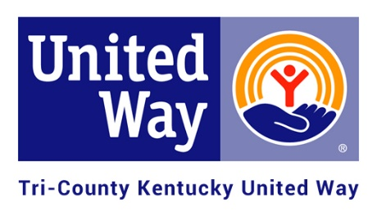
2020 APPLICATION FOR FUNDING
Checklist

The deadline for submission of this application is 12:00 noon on November 15th, 2019.

Eligibility:
Yes/No | Requirement
 | Are you a valid 501(c)3 organization or local school district program?
 | Do you serve individuals in Marion, Nelson and/or Washington Counties?
 | Are you a health and human service organization providing service in at least one of the following United Way priority areas: Education, Financial Stability or Health?

Required Information to be submitted:
Submitted | Requirement
 | Two (2) hard copies of your full application
 | Emailed a full application packet to director@tricountykyuw.org
 | Program budgets for the program for which you are seeking funding (please use attached forms).
 | Signed copy of Agency Agreement (please use attached form).
 | Anti-terrorism Compliance (please use attached form).
 | Most recent agency Financial Statement/Audit/990 (as applicable).
 | IRS letter confirming your exempt status under the 501(c)3 status or as a school.
 | Current Board roster with designation of officers and affiliations.
 | A copy of your Non-Discrimination Policy.
 | A success story from program for which you are seeking funding. Please do not use real names.
 | Program/Agency brochure.
 | Most recent annual report and/or newsletter, if applicable.
 | Copy of your registration with Kentucky Secretary of State (available through https://app.sos.ky.gov/ftsearch/).
 | Optional: Please provide a picture of your requested program’s services that can be used for marketing materials (social media, brochure, etc.).

Thank you!

